190905104
Parth Shukla
Lab 8

Study of Dynamic Routing Protocols using GNS3

1)

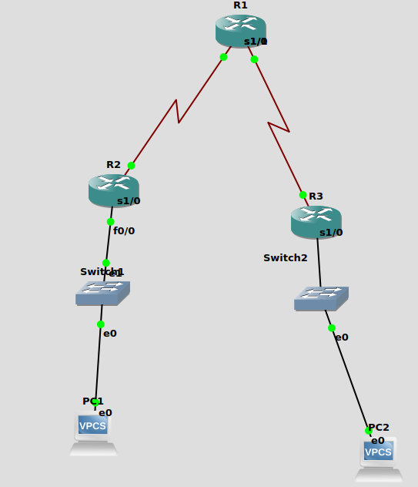

Setting up R1:

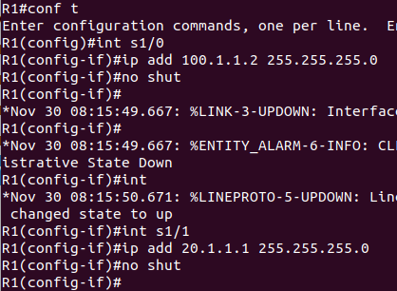

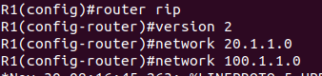

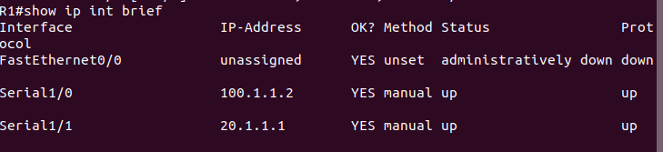

Setting up R2:
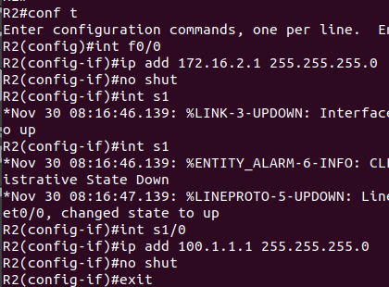

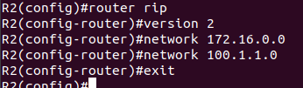

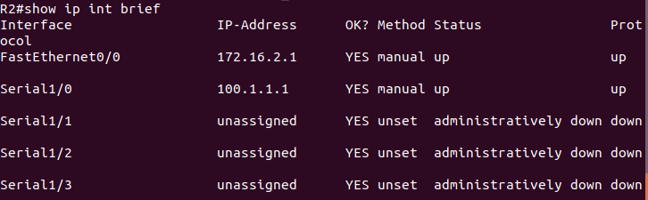

Setting up R3:
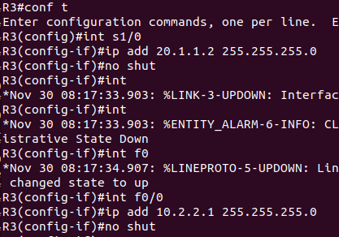

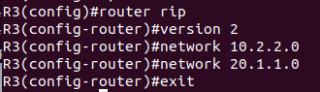

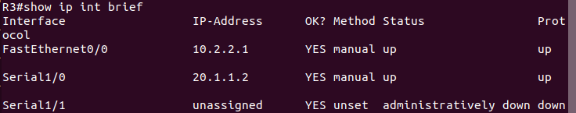

PC1:
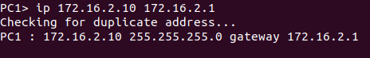

PC2:
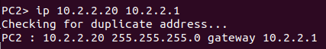

Checking if PC1 and PC2 can communicate:
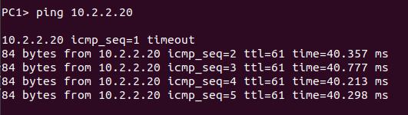

show ip route for R1:
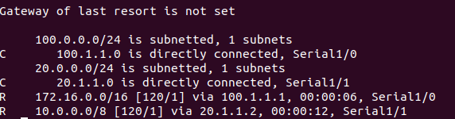

show ip route for R2:
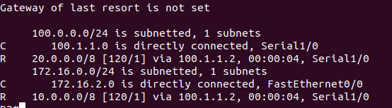
show ip route for R3:
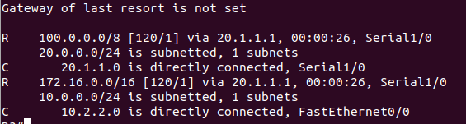

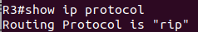

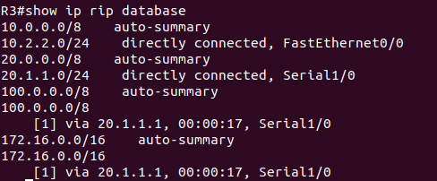

2)

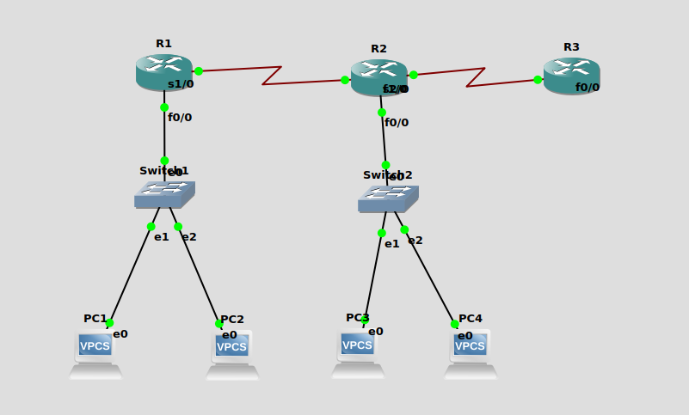

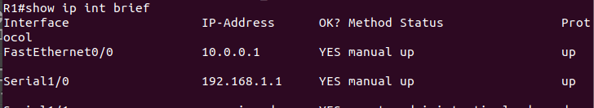
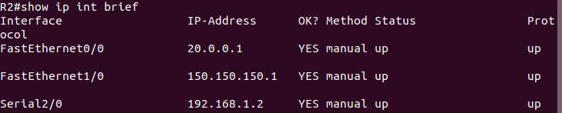
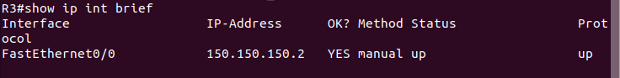

Ping PC3 from PC1
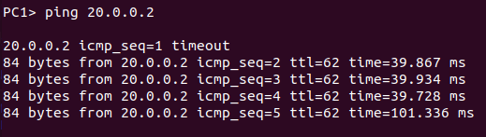
Ping R3 from PC1
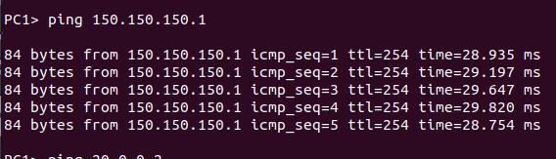

R2:
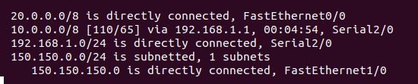
R3:
